|  |  |  |  |  |  |  |
| --- | --- | --- | --- | --- | --- | --- |
| |  |  |  |  | | --- | --- | --- | --- | | **logo ngan.png** | | **MINISTRY OF EDUCATION AND TRAINING** | | | **FPT UNIVERSITY** | | |
| Capstone Project Document |
| Maid Services |
| |  |  |  |  |  |  |  |  |  |  |  | | --- | --- | --- | --- | --- | --- | --- | --- | --- | --- | --- | | |  |  | | --- | --- | | **Group 06 – Report 1** | | | **Group member** | Bùi Tiến Tuân - Team Leader - SE60824  Mạnh Quang Tuyến - Team Member - SE60890  Trương Hải Đăng - Team Member - SE60841  Nguyễn Tấn Công - Team Member - SE60920 | | **Supervisor** | Mr. Nguyễn Trọng Tài | | **Ext. Supervisor** | N/A | | **Capstone Project code** | MS | | |

-Ho Chi Minh City, 09/2014-

# Table of Contents

Table of Contents 2

2.1 User Requirement Specification 3

2.1.1 Guest requirement 3

2.1.2 Staff requirement 3

2.1.3 Customer requirement 3

2.1.4 Maid mediator requirement 3

2.1.5 Maid requirement 4

2.1.6 Webmaster requirement 4

2.1.7 System requirement 4

2.2 System Requirement Specification 4

2.2.1 External Interface Requirements 4

2.2.1.1 User Interfaces 4

2.2.1.2 Hardware Interfaces 4

2.2.1.3 Software Interfaces 4

2.2.1.4 Communications Protocol 4

2.2.2 System Features 4

2.2.2.1 List of use case 4

2.2.2.2 Use Case model: 6

2.2.2.3 Use-case diagram 7

2.2.3 Software System Attributes 73

2.2.3.1 Reliability 73

2.2.3.2 Availability 73

2.2.3.3 Security 74

2.2.3.4 Maintainability 74

2.2.3.5 Portability 74

2.2.3.6 Performance 74

2.3 Entity Relationship Diagram or Data Structures 75

2.4 Other material (if any) 75



## User Requirement Specification

|  |  |
| --- | --- |
| Actor | Description |
| **Guest** | A person not login. They have some simple function search. |
| **Staff** | A person help staff and customer connect together and post job request for Maid |
| **Customer** | Hiring maids. They can search, comment rating for job request posted by Maid or Maid Mediator. |
| **Maid Mediator** | They help maid post job request. |
| **Maid** | They can post job request. |
| **Webmaster** | They manager website. |
| **System** | Implement suggestions. |

### Guest requirement

To satisfy the demand of guest, system has these functions:

* **Register Account:** guest need to register to become member.
* **Login:** when guest have account they can login with username and password.
* **Search:** guest can search information about jobs, before they determine become a member.
* **View JobRequest:** view JobRequest details.
* **View Recruitment:** view Recruitment details.
  + 1. **Authenticated User requirement**

After logging in, user becomes authenticated user and has these functions:

* **View Profile:** user can view profile.
* **Log out:** user can log out .
* **View JobRequest:** view JobRequest details.
* **View Recruitment:** view Recruitment details.
* **View Notifications:** view Notifications when system sends.
* **View Statistic:** view personal statistic.

### Staff requirement

A person: to manage the maid’s request, fee and allow maid to post request.

* **Manage post time**: staff manage maid’s request post time.
* **View post time**: staff can allow customer and maid the time that maid’s request posted.
* **Manage fee**: staff can manage the customer’s fee, maid’s fee
* **Confirm request**: staff can allow the maid’s request to post to the website.

### Customer requirement

A person:

* **Search maids**:
* **Rating**:
* **Comment**:
* **Manage recruitment**:
* **View customer statistic**:

### Maid mediator requirement

A person:

* **Apply job**:
* **Search jobs**:
* **Manage job request**:
* **View maid statistic**:

### Webmaster requirement

A person:

* **Manager user**:

### System requirement

A person:

* **Suggests**:
* **Handle unconfirmed request**:
* **Notify**:

## System Requirement Specification

### External Interface Requirements

#### User Interfaces

* The general interface of website is simple and simplifies user interfaces.
* The design is simple and monochrome is more prefer.
* The layout of information in page is showing simple but full of functions.
* The error, warning and notification messages must be simple, neat, and easy to understand. Error warning does not discomfort to the user.
* The working layout of user is spacious.
* Member can contact with manager and admin easily.

#### Hardware Interfaces

There is no extra hardware interfaces are needed. The system will use the standard hardware and data communications resources of a standard computer.

#### Software Interfaces

Browsers: Firefox, Chrome

#### Communications Protocol

BSF website uses HTTP/HTTPS protocol for communication with the web browser and the web server. In addition, TCP/IP network protocol for communication with HTTP protocol

### System Features

#### List of use case

|  |  |  |  |  |  |  |  |  |
| --- | --- | --- | --- | --- | --- | --- | --- | --- |
| No. | Use case name | Use case ID | Guest | Staff | Customer | Maid mediator | Webmaster | System |
| 1 | Register Account | 001 | x |  |  |  |  |  |
| 2 | Login | 002 | x |  |  |  |  |  |
| 3 | Search | 003 | x | x | x | x | x |  |
| 4 | Search by Age | 004 | x | x | x | x | x |  |
| 5 | Search by Skill | 005 | x | x | x | x | x |  |
| 6 | Search by Gender | 006 | x | x | x | x | x |  |
| 7 | Search by Salary | 007 | x | x | x | x | x |  |
| 8 | Search by Time | 008 | x | x | x | x | x |  |
| 9 | View JobRequest | 009 | x | x | x | x | x |  |
| 10 | View Recruitment | 010 | x | x | x | x | x |  |
| 11 | View Profile | 011 | x | x | x | x | x |  |
| 12 | Log out | 012 | x | x | x | x | x |  |
| 13 | View Notifications | 013 |  | x | x | x | x |  |
| 14 | Add Staff | 014 |  |  |  |  | x |  |
| 15 | Manage User | 015 |  |  |  |  | x |  |
| 16 | Ban Account | 016 |  |  |  |  | x |  |
| 17 | Unban Account | 017 |  |  |  |  | x |  |
| 18 | View Requests Statistic | 018 |  | x |  |  | x |  |
| 19 | View Income Statistic | 019 |  | x |  |  | x |  |
| 20 | Manage Config | 020 |  |  |  |  | x |  |
| 21 | Suggest | 021 |  |  |  |  |  | x |
| 22 | Send SMS | 022 |  |  |  |  |  | x |
| 23 | Send Notifications | 023 |  |  |  |  |  | x |
| 24 | Apply JobRequest | 024 |  |  | x |  |  |  |
| 25 | Comment JobRequest | 025 |  |  | x |  |  |  |
| 26 | Rate JobRequest | 026 |  |  | x |  |  |  |
| 27 | Edit Customer Profile | 027 |  |  | x |  |  |  |
| 28 | Extend Recruitment | 028 |  |  | x |  |  |  |
| 29 | Hide Recruitment | 029 |  |  | x |  |  |  |
| 30 | Public Recruitment | 030 |  |  | x |  |  |  |
| 31 | Post Recruitment | 031 |  |  | x |  |  |  |
| 32 | Edit Recruitment | 032 |  |  | x |  |  |  |
| 33 | Pay | 033 |  |  | x |  |  |  |
| 34 | View Customer Statistic | 034 |  |  | x |  |  |  |
| 35 | Add Maid | 035 |  | x |  | x |  |  |
| 36 | View Maid | 036 |  | x |  | x |  |  |
| 37 | Edit Maid | 037 |  | x |  | x |  |  |
| 38 | Public JobRequest | 038 |  | x |  | x |  |  |
| 39 | Hide JobRequest | 039 |  | x |  | x |  |  |
| 40 | Extend JobRequest | 040 |  | x |  | x |  |  |
| 41 | Edit JobRequest | 041 |  | x |  | x |  |  |
| 42 | Edit Maid Mediator Profile | 042 |  |  |  | x |  |  |
| 43 | Post JobRequest | 043 |  | x |  | x |  |  |
| 44 | Active Recruitment | 044 |  | x |  |  |  |  |
| 45 | Approved JobRequest | 045 |  | x |  |  |  |  |
| 46 | View Request Statistic | 046 |  | x |  |  | x |  |
| 47 | View Income Statistic | 047 |  | x |  |  | x |  |
| 48 | View Maid Manager Statistic | 048 |  | x |  | x |  |  |
| 49 | Edit Maid Manager Profile | 049 |  | x |  | x |  |  |
| 50 | Manage Number of Kmean | 050 |  |  |  |  | x |  |
| 51 | Manage Number of Weeks | 051 |  |  |  |  | x |  |
| 52 | Manage JobRequest Price | 052 |  |  |  |  | x |  |
| 53 | Manage Recruitment Price | 053 |  |  |  |  | x |  |
| 54 | Manage JobRequest | 054 |  | x |  |  |  |  |
| 55 | Manage Recruitment | 055 |  | x |  |  |  |  |
| 56 | Manage Applied JobRequest | 056 |  | x |  |  |  |  |
| 57 | Active JobRequest | 057 |  | x |  |  |  |  |
| 58 | Active Recruitment | 058 |  | x |  |  |  |  |
| 59 | Approve JobRequest | 059 |  | x |  |  |  |  |

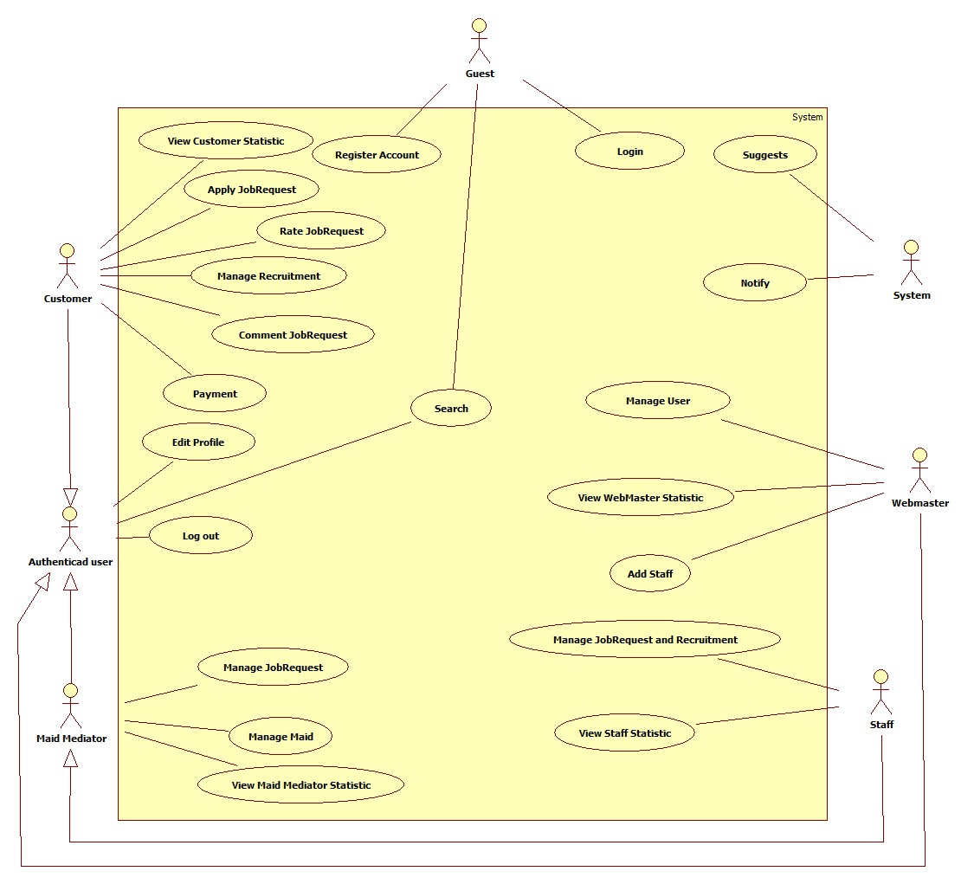

#### Use Case model:

#### Use-case diagram

##### <Guest> Register

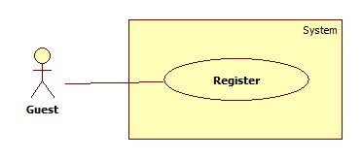

|  |  |  |  |  |
| --- | --- | --- | --- | --- |
| **USE CASE SPECIFICATION** | | | | |
| **Use-case No.** | UC001 | **Use-case Version** | | 1.0 |
| **Use-case Name** | Register | | | |
| **Author** | CongNT | | | |
| **Date** | 21/09/2014 | **Priority** | High | |
| **Actor:** Guest  **Summary:** This use case allows guest create an account in website system.  **Goal:**  It helps guest to create an account on website.  **Trigger:** Click on the “Đăng ký” button to register on home page  **Pre-conditions:**   * Page is loaded successfully * Register page will be shown   **Post conditions:**   * Success: Register successfully, guest will have an account in system and will be logged into system. * Failure: Show message error.   **Main Success Scenario:**   |  |  | | --- | --- | | Actor Action | System Response | | 1. Click on “Đăng ký” button home page 2. Input right information about username, email, password, full name, city, district, address, phone 3. Click on the “Đăng ký” button [Alternative 1] | 2. System redirect to register page for guest, contain a register form :   * Tên tài khoản [Username: textbox ] * Mật khẩu [Password : textbox] * Nhập lại mật khẩu [Repassword : textbox] * Địa chỉ email [Email: textbox]   In format: /^([a-zA-Z0-9_\.\-])+\@(([a-zA-Z0-9\-])+\.)+([a-zA-Z0-9]{2,4})+$/ .   * Họ và tên [Fullname : textbox] * Điện thoại[Phone : textbox] * Vai trò[Role : dropdownlist] * Đăng ký[button]  1. Validate valid username, password, email, phone 2. Redirect to register success page [Exception 1,2 3,4] |   **Alternative Scenario:**   |  |  | | --- | --- | | Actor Action | System Response | | 1. [Alternative 1] Click on the “MaidService” icon. | 1. Back to home page |   **Exceptions:**   |  |  | | --- | --- | | Actor Action | System Response | | 1. “Tên đăng nhập”,”Mật khẩu” ,”nhập lại mật khẩu” “Email” text-box is empty | 1. Display message: “Vui lòng nhập tên đăng nhập” or “Vui lòng nhập mật khẩu” or “Mật khẩu không trùng khớp” or “Vui lòng nhập số” or “Vui lòng nhập đúng định dạng abc@abc.abc” |   **Relationships:** N/A  **Business Rules:** N/A | | | | |

##### <System> Suggest

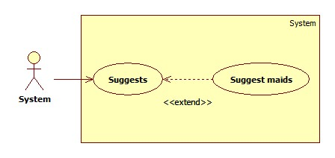

|  |  |  |  |  |
| --- | --- | --- | --- | --- |
| **USE CASE SPECIFICATION** | | | | |
| **Use-case No.** | UC019 | **Use-case Version** | | 1.0 |
| **Use-case Name** | Suggest maids | | | |
| **Author** | TuanBT | | | |
| **Date** | 24/09/2014 | **Priority** | High | |
| **Actor:** System  **Summary:** system automatically suggest maids for customer when they post a recruitment on MS-Website.  **Goal:**  The use case will help MS-Website suggest maids for customer when they post a recruitment.  **Trigger:**   * Click [Yêu cầu công việc] button. * Fill all data. * Click [Đăng yêu cầu] button.   **Pre-conditions:**   * Post an invalid recruitment.   **Post conditions:**   * Success: List maid will appear by suggestion criteria. * Failure: List maid upcoming will appear by create date order.   **Main Success Scenario:**   |  |  | | --- | --- | | Actor Action | System Response | | 1. User click on the [Đăng yêu cầu] button.   [Alternative 1] | 1. Show list jobs request by suggest criteria.   [Exception 1] |   **Alternative Scenario:**   |  |  | | --- | --- | | Actor Action | System Response | | 1. User click on the [Đăng yêu cầu] button. | 1. Show list jobs request by suggest criteria. |   **Exceptions:**   |  |  | | --- | --- | | Actor Ation | System Response | | 1. System fail to load data | 1. Show list jobs request |   **Relationships:** N/A  **Business Rules:**  When customer post a recruitment, system calculate jobs request this nearer than recruitment. | | | | |

##### <System> Notify

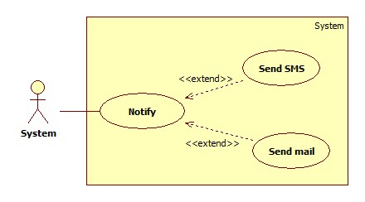

|  |  |  |  |  |
| --- | --- | --- | --- | --- |
| **USE CASE SPECIFICATION** | | | | |
| **Use-case No.** | UC020 | **Use-case Version** | | 1.0 |
| **Use-case Name** | Notify | | | |
| **Author** |  | | | |
| **Date** | 24/09/2014 | **Priority** | Normal | |
| **Actor:** System  **Summary:** Notify for Maid and Customer when they apply together.  **Goal:**  Send mail and SMS to Maid and Customer when apply. System know when accept a job.  **Trigger:** Both Customer and Maid post an invalid recruitment and job request. They apply together.  **Pre-conditions:**   * Apply success.   **Post conditions:**   * Success: Send email and SMS * Failure: An error message on screen   **Main Success Scenario:**   |  |  | | --- | --- | | Actor Action | System Response | | 1. System receive Customer and Maid apply | 2 Send email and SMS  [Exception 1] |   **Alternative Scenario:**   |  |  | | --- | --- | | Actor Action | System Response | | N/A | N/A |   **Exceptions:**   |  |  | | --- | --- | | Actor Action | System Response | | 1. Email or phone number is blank | 1. Show error “Không thể gửi email hoặc tin nhắn” |   **Relationships:** N/A  **Business Rules:** System must send email or SMS, help maid or customer know when request of them apply. | | | | |

##### <Guest> Login

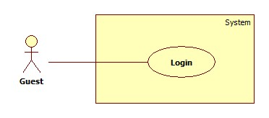

|  |  |  |  |  |
| --- | --- | --- | --- | --- |
| **USE CASE SPECIFICATION** | | | | |
| **Use-case No.** | UC002 | **Use-case Version** | | 1.0 |
| **Use-case Name** | Login | | | |
| **Author** | CongNT | | | |
| **Date** | 21/09/2014 | **Priority** | High | |
| **Actor:** Guest  **Summary:** This use case allow guest to login the website  **Goal:** Guest become a member of the website  **Trigger:** Click on the “Đăng nhập” button to login on home page  **Pre-conditions:**   * Page is loaded successfully * The login page will shown   **Post conditions:**   * Success: Login successfully, guest will have a role in system and can use more function of system. * Failure: Show message error   **Main Success Scenario:**   |  |  | | --- | --- | | Actor Action | System Response | | 1. Click on “Đăng nhập” button home page 2. Input right information about username, password 3. Click on the “Đăng nhập” button | 1. System redirect to login page for guest, contain a login form :  * Tên tài khoản [Username: textbox ] * Mật khẩu [Password : textbox] * Đăng nhập [button]  1. Redirect to login successful page |   **Alternative Scenario:**   |  |  | | --- | --- | | Actor Action | System Response | | 1. [Alternative 1] Click on the “Đóng” button. | 1. Back to home page |   **Exceptions:**   |  |  | | --- | --- | | Actor Action | System Response | | 1. “Tên đăng nhập”,”Mật khẩu” ,” is empty 2. “Tên đăng nhập”,”Mật khẩu” ,” is incorrect | 1. Display message “Vui lòng nhập tên đăng nhập” or “Vui lòng nhập mật khẩu” 2. Display message “Tên đăng nhập hoặc mật khẩu không đúng, vui lòng thử lại” |   **Relationships:** N/A  **Business Rules:** N/A | | | | |

##### <Guest > Search

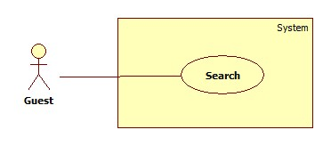

|  |  |  |  |  |
| --- | --- | --- | --- | --- |
| **USE CASE SPECIFICATION** | | | | |
| **Use-case No.** | UC003 | **Use-case Version** | | 1.0 |
| **Use-case Name** | Search | | | |
| **Author** | CongNT | | | |
| **Date** | 21/09/2014 | **Priority** | High | |
| **Actor:** Guest  **Summary:** This use case allow guest can search information by job  **Goal:** Guest can search information by search job  **Trigger:** Fill in “Tìm kiếm” textbox, then click on “Tìm kiếm” button  **Pre-conditions:**   * Page is loaded successfully * The search page will shown   **Post conditions:**   * Success: Search successfully, the system will shown search result * Failure:   **Main Success Scenario:**   |  |  | | --- | --- | | Actor Action | System Response | | 1. Fill in “Tìm kiếm” text box 2. Click on “Tìm kiếm” button | 1. System redirect to search page for guest and show search results |   **Alternative Scenario:**   |  |  | | --- | --- | | Actor Action | System Response | | 1. [Alternative 1] Click on the “MaidService” icon | 1. Back to home page |   **Exceptions:**   |  |  | | --- | --- | | Actor Action | System Response | |  |  |   **Relationships:** N/A  **Business Rules:** N/A | | | | |

##### < Guest >Advance Search

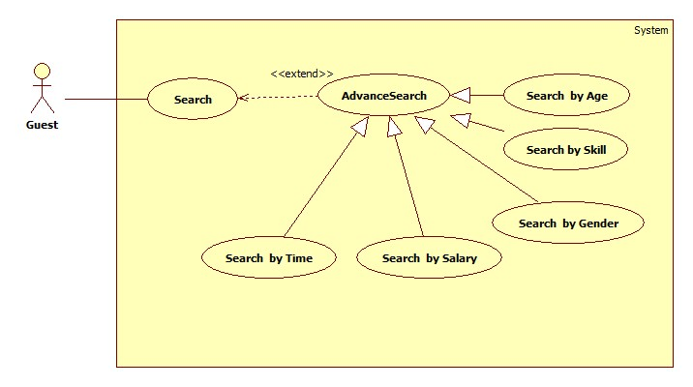

###### **<Guest> Search by job**

|  |  |  |  |  |
| --- | --- | --- | --- | --- |
| **USE CASE SPECIFICATION** | | | | |
| **Use-case No.** | UC005 | **Use-case Version** | | 1.0 |
| **Use-case Name** | Search by name | | | |
| **Author** | CongNT | | | |
| **Date** | 21/09/2014 | **Priority** | High | |
| **Actor:** Guest  **Summary:** This use case allow guest can search information by job  **Goal:** Guest can search information by search job  **Trigger:** Fill in “Tìm kiếm” textbox, then click on “Tìm kiếm” button  **Pre-conditions:**   * Page is loaded successfully * The search page will shown   **Post conditions:**   * Success: Search successfully, the system will shown search result * Failure:   **Main Success Scenario:**   |  |  | | --- | --- | | Actor Action | System Response | | 1. Fill in “Tìm kiếm” text box 2. Click on “Tìm kiếm” button 3. Click on “Nấu ăn” or “trông trẻ” link | 1. System redirect to search page for guest 2. Show the result suitable for each link |   **Alternative Scenario:**   |  |  | | --- | --- | | Actor Action | System Response | | 1. [Alternative 1] Click on the “Đóng” button. | 1. Back to home page |   **Exceptions:**   |  |  | | --- | --- | | Actor Action | System Response | |  |  |   **Relationships:** N/A  **Business Rules:** N/A | | | | |

###### **<Guest> Search by age**

|  |  |  |  |  |
| --- | --- | --- | --- | --- |
| **USE CASE SPECIFICATION** | | | | |
| **Use-case No.** | UC003a | **Use-case Version** | | 1.0 |
| **Use-case Name** | Search by age | | | |
| **Author** | CongNT | | | |
| **Date** | 21/09/2014 | **Priority** | High | |
| **Actor:** Guest  **Summary:** This use case allow guest can search information by age  **Goal:** Guest can search information by search age  **Trigger:** Fill in “Tìm kiếm” textbox, then click on “Tìm kiếm” button  **Pre-conditions:**   * Page is loaded successfully * The search page will shown   **Post conditions:**   * Success: Search successfully, the system will shown search result * Failure:   **Main Success Scenario:**   |  |  | | --- | --- | | Actor Action | System Response | | 1. Fill in “Tìm kiếm” text box 2. Click on “Tìm kiếm” button 3. Click on “25-30” or “30-35” or “35-40” link | 1. System redirect to search page for guest 2. Show the result suitable for each link |   **Alternative Scenario:**   |  |  | | --- | --- | | Actor Action | System Response | | 1. [Alternative 1] Click on the “Đóng” button. | 1. Back to home page |   **Exceptions:**   |  |  | | --- | --- | | Actor Action | System Response | |  |  |   **Relationships:** N/A  **Business Rules:** N/A | | | | |

###### **<Guest> Search by salary**

|  |  |  |  |  |
| --- | --- | --- | --- | --- |
| **USE CASE SPECIFICATION** | | | | |
| **Use-case No.** | UC006 | **Use-case Version** | | 1.0 |
| **Use-case Name** | Search by salary | | | |
| **Author** | CongNT | | | |
| **Date** | 21/09/2014 | **Priority** | High | |
| **Actor:** Guest  **Summary:** This use case allow guest can search information by salary  **Goal:** Guest can search information by search salary  **Trigger:** Fill in “Tìm kiếm” textbox, then click on “Tìm kiếm” button  **Pre-conditions:**   * Page is loaded successfully * The search page will shown   **Post conditions:**   * Success: Search successfully, the system will shown search result * Failure:   **Main Success Scenario:**   |  |  | | --- | --- | | Actor Action | System Response | | 1. Fill in “Tìm kiếm” text box 2. Click on “Tìm kiếm” button 3. Click on “Dưới 3 triệu” or “3-5 triệu” or “trên 5 triệu” link | 1. System redirect to search page for guest 2. Show the result suitable for each link |   **Alternative Scenario:**   |  |  | | --- | --- | | Actor Action | System Response | | 1. [Alternative 1] Click on the “Đóng” button. | 1. Back to home page |   **Exceptions:**   |  |  | | --- | --- | | Actor Action | System Response | |  |  |   **Relationships:** N/A  **Business Rules:** N/A | | | | |

###### **<Guest> Search by time**

|  |  |  |  |  |
| --- | --- | --- | --- | --- |
| **USE CASE SPECIFICATION** | | | | |
| **Use-case No.** | UC007 | **Use-case Version** | | 1.0 |
| **Use-case Name** | Search by time | | | |
| **Author** | CongNT | | | |
| **Date** | 21/09/2014 | **Priority** | High | |
| **Actor:** Guest  **Summary:** This use case allow guest can search information by time  **Goal:** Guest can search information by search time  **Trigger:** Fill in “Tìm kiếm” textbox, then click on “Tìm kiếm” button  **Pre-conditions:**   * Page is loaded successfully * The search page will shown   **Post conditions:**   * Success: Search successfully, the system will shown search result * Failure:   **Main Success Scenario:**   |  |  | | --- | --- | | Actor Action | System Response | | 1. Fill in “Tìm kiếm” text box 2. Click on “Tìm kiếm” button 3. Click on “Cách đây 1 ngày” or “Cách đây 3 ngày” or “Cách đây 5 ngày” or “Cách đây 7 ngày” or “Cách đây 14 ngày” or “Cách đây 30 ngày” link | 1. System redirect to search page for guest 2. Show the result suitable for each link |   **Alternative Scenario:**   |  |  | | --- | --- | | Actor Action | System Response | | 1. [Alternative 1] Click on the “Đóng” button. | 1. Back to home page |   **Exceptions:**   |  |  | | --- | --- | | Actor Action | System Response | |  |  |   **Relationships:** N/A  **Business Rules:** N/A | | | | |

###### **<Guest> Search by gender**

|  |  |  |  |  |
| --- | --- | --- | --- | --- |
| **USE CASE SPECIFICATION** | | | | |
| **Use-case No.** | UC008 | **Use-case Version** | | 1.0 |
| **Use-case Name** | Search by gender | | | |
| **Author** | CongNT | | | |
| **Date** | 21/09/2014 | **Priority** | High | |
| **Actor:** Guest  **Summary:** This use case allow guest can search information by gender  **Goal:** Guest can search information by search name  **Trigger:** Fill in “Tìm kiếm” textbox, then click on “Tìm kiếm” button  **Pre-conditions:**   * Page is loaded successfully * The search page will shown   **Post conditions:**   * Success: Search successfully, the system will shown search result * Failure:   **Main Success Scenario:**   |  |  | | --- | --- | | Actor Action | System Response | | 1. Fill in “Tìm kiếm” text box 2. Click on “Tìm kiếm” button 3. Click on “Nam” or “Nữ” link | 1. System redirect to search page for guest 2. Show the result suitable for each link |   **Alternative Scenario:**   |  |  | | --- | --- | | Actor Action | System Response | | 1. [Alternative 1] Click on the “Đóng” button. | 1. Back to home page |   **Exceptions:**   |  |  | | --- | --- | | Actor Action | System Response | |  |  |   **Relationships:** N/A  **Business Rules:** N/A | | | | |

##### <Staff> Manage JobRequest and Recruitment

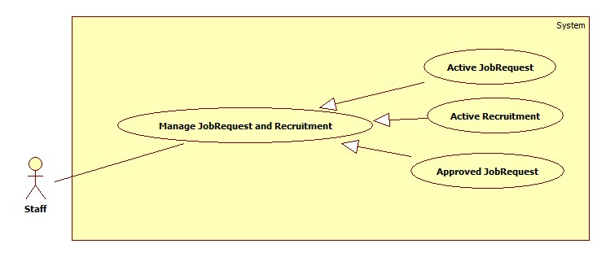

###### **<Staff> Active JobRequest**

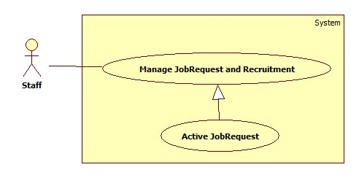

|  |  |  |  |  |
| --- | --- | --- | --- | --- |
| **USE CASE SPECIFICATION** | | | | |
| **Use-case No.** | UC038 | **Use-case Version** | | 1.0 |
| **Use-case Name** | Active JobRequest | | | |
| **Author** | CongNT | | | |
| **Date** | 21/09/2014 | **Priority** | High | |
| **Actor:** Staff  **Summary:** This use case allow staff to active job request to public it on website  **Goal:** Staff can allow job request to public on website  **Trigger:** User login as staff  **Pre-conditions:**   * Page is loaded successfully * User login as staff successful   **Post conditions:**   * Success: Login successfully, the job request will be allowed to public on website * Failure:   **Main Success Scenario:**   |  |  | | --- | --- | | Actor Action | System Response | | 1. Login as a staff 2. Choose a job request, click “Kích hoạt” button 3. Click “Chấp nhận” button. | 1. System redirect to list of job request 2. System show a “Xác nhận kích hoạt” pop up. 3. Change IsActive(false) to IsActive(true) and save change to database |   **Alternative Scenario:**   |  |  | | --- | --- | | Actor Action | System Response | | 1. Click on the “Đăng xuất” button. | 1. Clear session and back to home page |   **Exceptions:**   |  |  | | --- | --- | | Actor Action | System Response | | 1. System fail to load data | 1. Show message “Hệ thống đang bảo trì” |   **Relationships:** N/A  **Business Rules:** Staff | | | | |

###### **<Staff> Active Recruitment**

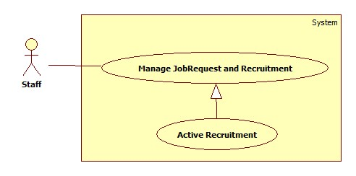

|  |  |  |  |  |
| --- | --- | --- | --- | --- |
| **USE CASE SPECIFICATION** | | | | |
| **Use-case No.** | UC039 | **Use-case Version** | | 1.0 |
| **Use-case Name** | Active Recruitment | | | |
| **Author** | CongNT | | | |
| **Date** | 21/09/2014 | **Priority** | High | |
| **Actor:** Staff  **Summary:** This use case allow staff to active job request to public it on website  **Goal:** Staff can allow job request to public on website  **Trigger:** User login as staff  **Pre-conditions:**   * Page is loaded successfully * User login as staff successful   **Post conditions:**   * Success: Login successfully, the job request will be allowed to public on website * Failure:   **Main Success Scenario:**   |  |  | | --- | --- | | Actor Action | System Response | | 1. Login as a staff 2. Click “Xác nhận hoàn tất công việc” link 3. Choose a recruitment, click “Hoàn tất” button 4. Click “Chấp nhận” button. | 1. System redirect to list of job request 2. System redirect to list of applied job requests 3. System show a “Xác nhận kích hoạt” pop up. 4. Change IsActive(false) to IsActive(true) and save change to database |   **Alternative Scenario:**   |  |  | | --- | --- | | Actor Action | System Response | | 1. Click on the “Đăng xuất” button. | 1. Clear session and back to home page |   **Exceptions:**   |  |  | | --- | --- | | Actor Action | System Response | | 1. System fail to load data | 1. Show message “Hệ thống đang bảo trì” |   **Relationships:** N/A  **Business Rules:** Staff | | | | |

###### **<Staff> Approve JobRequest**

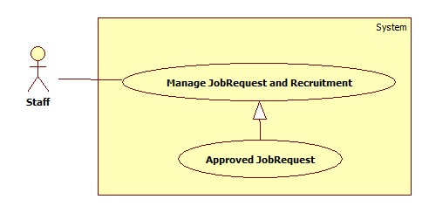

|  |  |  |  |  |
| --- | --- | --- | --- | --- |
| **USE CASE SPECIFICATION** | | | | |
| **Use-case No.** | UC040 | **Use-case Version** | | 1.0 |
| **Use-case Name** | Approve JobRequest | | | |
| **Author** | CongNT | | | |
| **Date** | 21/09/2014 | **Priority** | High | |
| **Actor:** Staff  **Summary:** This use case allow staff to active job request to public it on website  **Goal:** Staff can allow job request to public on website  **Trigger:** User login as staff  **Pre-conditions:**   * Page is loaded successfully * User login as staff successful   **Post conditions:**   * Success: Login successfully, the job request will be allowed to public on website * Failure:   **Main Success Scenario:**   |  |  | | --- | --- | | Actor Action | System Response | | 1. Login as a staff 2. Click “Kích hoạt yêu cầu tìm người” link 3. Choose a recruitment, click “Kích hoạt” button 4. Click “Chấp nhận” button. | 1. System redirect to list of job request 2. System redirect to list of recruitments 3. System show a “Xác nhận kích hoạt” pop up. 4. Change IsActive(false) to IsActive(true) and save change to database |   **Alternative Scenario:**   |  |  | | --- | --- | | Actor Action | System Response | | 1. Click on the “Đăng xuất” button. | 1. Clear session and back to home page |   **Exceptions:**   |  |  | | --- | --- | | Actor Action | System Response | | 1. System fail to load data | 1. Show message “Hệ thống đang bảo trì” |   **Relationships:** N/A  **Business Rules:** Staff | | | | |

##### <Staff> View Staff Statistic

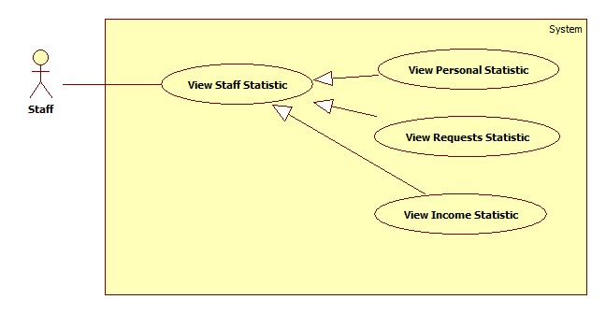

###### **<Staff> View Personal Statistic**

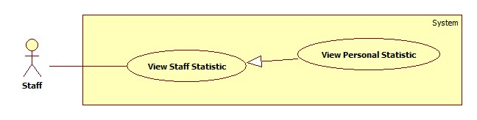

|  |  |  |  |  |
| --- | --- | --- | --- | --- |
| **USE CASE SPECIFICATION** | | | | |
| **Use-case No.** | UC034 | **Use-case Version** | | 1.0 |
| **Use-case Name** | View Personal Statistic | | | |
| **Author** | CongNT | | | |
| **Date** | 21/09/2014 | **Priority** | High | |
| **Actor:** Staff  **Summary:** This use case allow staff see personal statistic  **Goal:** Staff can see own statistic  **Trigger:** User login as staff  **Pre-conditions:**   * Page is loaded successfully * User login as staff successful   **Post conditions:**   * Success: Login successfully, the statistic will be shown * Failure:   **Main Success Scenario:**   |  |  | | --- | --- | | Actor Action | System Response | | 1. Login as a staff 2. Click name link 3. Click “Thống kê” link | 1. System redirect home page 2. System redirect personal profile page 3. System redirect personal statistic page and show personal statistic. |   **Alternative Scenario:**   |  |  | | --- | --- | | Actor Action | System Response | | 1. Click on the “Đăng xuất” button. | 1. Clear session and back to home page |   **Exceptions:**   |  |  | | --- | --- | | Actor Action | System Response | | 1. System fail to load data | 1. Show message “Hệ thống đang bảo trì” |   **Relationships:** N/A  **Business Rules:** Staff | | | | |

###### **<Staff> View Requests Statistic**

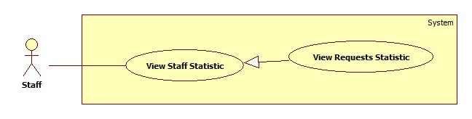

|  |  |  |  |  |
| --- | --- | --- | --- | --- |
| **USE CASE SPECIFICATION** | | | | |
| **Use-case No.** | UC042 | **Use-case Version** | | 1.0 |
| **Use-case Name** | View Requests Statistic | | | |
| **Author** | CongNT | | | |
| **Date** | 21/09/2014 | **Priority** | High | |
| **Actor:** Staff  **Summary:** This use case allow staff see requests statistic  **Goal:** Staff can see requests statistic  **Trigger:** User login as staff  **Pre-conditions:**   * Page is loaded successfully * User login as staff successful   **Post conditions:**   * Success: Login successfully, the statistic will be shown * Failure:   **Main Success Scenario:**   |  |  | | --- | --- | | Actor Action | System Response | | 1. Login as a staff 2. Click name link 3. Click “Thống kê” link 4. Click “Các yêu cầu” link | 1. System redirect home page 2. System redirect personal profile page 3. System redirect personal statistic page and show personal statistic. 4. System redirect personal statistic page and show personal statistic. |   **Alternative Scenario:**   |  |  | | --- | --- | | Actor Action | System Response | | 1. Click on the “Đăng xuất” button. | 1. Clear session and back to home page |   **Exceptions:**   |  |  | | --- | --- | | Actor Action | System Response | | 1. System fail to load data | 1. Show message “Hệ thống đang bảo trì” |   **Relationships:** N/A  **Business Rules:** Staff | | | | |

###### **<Staff> View Income Statistic**

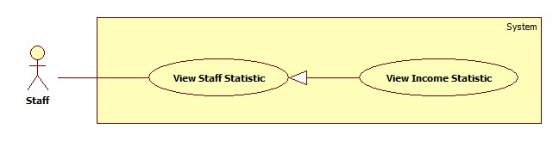

|  |  |  |  |  |
| --- | --- | --- | --- | --- |
| **USE CASE SPECIFICATION** | | | | |
| **Use-case No.** | UC043 | **Use-case Version** | | 1.0 |
| **Use-case Name** | View Income Statistic | | | |
| **Author** | CongNT | | | |
| **Date** | 21/09/2014 | **Priority** | High | |
| **Actor:** Staff  **Summary:** This use case allow staff see income statistic  **Goal:** Staff can see income statistic  **Trigger:** User login as staff  **Pre-conditions:**   * Page is loaded successfully * User login as staff successful   **Post conditions:**   * Success: Login successfully, the income statistic will be shown * Failure:   **Main Success Scenario:**   |  |  | | --- | --- | | Actor Action | System Response | | 1. Login as a staff 2. Click name link 3. Click “Thống kê” link 4. Click “Doanh thu” link | 1. System redirect home page 2. System redirect personal profile page 3. System redirect personal statistic page and show personal statistic. 4. System redirect income statistic page and show personal statistic. |   **Alternative Scenario:**   |  |  | | --- | --- | | Actor Action | System Response | | 1. Click on the “Đăng xuất” button. | 1. Clear session and back to home page |   **Exceptions:**   |  |  | | --- | --- | | Actor Action | System Response | | 1. System fail to load data | 1. Show message “Hệ thống đang bảo trì” |   **Relationships:** N/A  **Business Rules:** Staff | | | | |

##### <Staff> Manage Maid

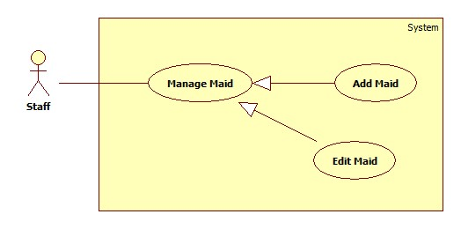

###### **<Staff> Add Maid**

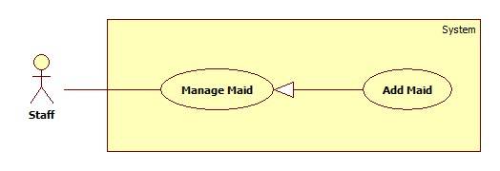

|  |  |  |  |  |
| --- | --- | --- | --- | --- |
| **USE CASE SPECIFICATION** | | | | |
| **Use-case No.** | UC035 | **Use-case Version** | | 1.0 |
| **Use-case Name** | Add maid | | | |
| **Author** | CongNT | | | |
| **Date** | 21/09/2014 | **Priority** | High | |
| **Actor:** Staff  **Summary:** This use case allow staff to add maids for management.  **Goal:** Staff can add maids  **Trigger:** User login as staff  **Pre-conditions:**   * Page is loaded successfully * User login as staff successful   **Post conditions:**   * Success: Login successfully, staff can add maids * Failure: Show messages   **Main Success Scenario:**   |  |  | | --- | --- | | Actor Action | System Response | | 1. Login as a staff 2. Click name link 3. Click “Thêm người tuyển việc” link | 1. System redirect home page 2. System redirect personal profile page 3. System redirect add maid page with following field:  * Họ và tên [MaidName: textbox] * Kinh nghiệm [Experience: dropdownlist] * Số điện thoại [Phone: textbox] * Ngày sinh [BirthDate: textbox] * Giới tính [Gender: dropdownlist] * Biết tiếng [LanguageEnglish: checkbox, LanguageChina: checkbox, LanguageJapanese: checkbox, LanguageKorean: checkbox] * Nguyên quán [Hometown: dropdownlist] * Đang sống tại [Address: dropdownlist] * Kết hôn [Married: dropdownlist] * Giới thiệu bản thân [Description: textbox] * “Hoàn tất người giúp việc” button. |   **Alternative Scenario:**   |  |  | | --- | --- | | Actor Action | System Response | | 1. Click on the “Đăng xuất” button. | 1. Clear session and back to home page |   **Exceptions:**   |  |  | | --- | --- | | Actor Action | System Response | | 1. “Họ và tên” is empty 2. “Số điện thoại” is empty or not a numberic value 3. “Ngày sinh” is empty | 1. Show message “Vui lòng nhập tên người giúp việc” 2. Show message “Vui lòng nhập số” 3. Show message “Vui lòng chọn ngày sinh” |   **Relationships:** N/A  **Business Rules:** Staff | | | | |

###### **<Staff> Edit Maid**

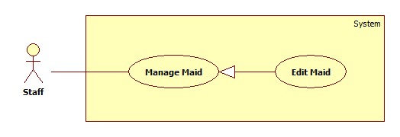

|  |  |  |  |  |
| --- | --- | --- | --- | --- |
| **USE CASE SPECIFICATION** | | | | |
| **Use-case No.** | UC042 | **Use-case Version** | | 1.0 |
| **Use-case Name** | Edit maid | | | |
| **Author** | CongNT | | | |
| **Date** | 21/09/2014 | **Priority** | High | |
| **Actor:** Staff  **Summary:** This use case allow staff edit own maids  **Goal:** Staff can edit own maids  **Trigger:** User login as staff  **Pre-conditions:**   * Page is loaded successfully * User login as staff successful   **Post conditions:**   * Success: Login successfully, staff can edit maids * Failure:   **Main Success Scenario:**   |  |  | | --- | --- | | Actor Action | System Response | | 1. Login as a staff 2. Click name link 3. Click maid name link 4. Click “Sửa thông tin người giúp việc” link | 1. System redirect home page 2. System redirect personal profile page 3. System redirect maid profile page 4. System redirect add maid page with following field:  * Họ và tên [MaidName: textbox] * Kinh nghiệm [Experience: dropdownlist] * Số điện thoại [Phone: textbox] * Ngày sinh [BirthDate: textbox] * Giới tính [Gender: dropdownlist] * Biết tiếng [LanguageEnglish: checkbox, LanguageChina: checkbox, LanguageJapanese: checkbox, LanguageKorean: checkbox] * Nguyên quán [Hometown: dropdownlist] * Đang sống tại [Address: dropdownlist] * Kết hôn [Married: dropdownlist] * Giới thiệu bản thân [Description: textbox] * “Hoàn tất người giúp việc” button. |   **Alternative Scenario:**   |  |  | | --- | --- | | Actor Action | System Response | | 1. Click on the “Đăng xuất” button. | 1. Clear session and back to home page |   **Exceptions:**   |  |  | | --- | --- | | Actor Action | System Response | | 1. “Họ và tên” is empty 2. “Số điện thoại” is empty or not a numberic value 3. “Ngày sinh” is empty | 1. Show message “Vui lòng nhập tên người giúp việc” 2. Show message “Vui lòng nhập số” 3. Show message “Vui lòng chọn ngày sinh” |   **Relationships:** N/A  **Business Rules:** Staff | | | | |

##### <Staff> Manage JobRequest

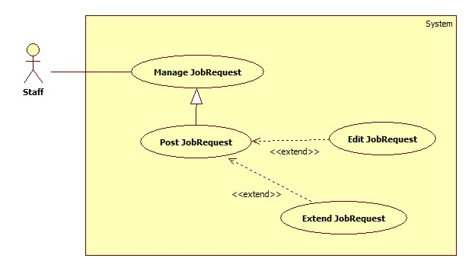

###### **<Staff> Post JobRequest**

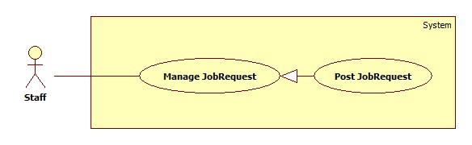

|  |  |  |  |  |
| --- | --- | --- | --- | --- |
| **USE CASE SPECIFICATION** | | | | |
| **Use-case No.** | UC037 | **Use-case Version** | | 1.0 |
| **Use-case Name** | Post jobrequest | | | |
| **Author** | CongNT | | | |
| **Date** | 21/09/2014 | **Priority** | High | |
| **Actor:** Staff  **Summary:** This use case allow staff to post jobrequest  **Goal:** Staff can post jobrequest  **Trigger:** User login as staff  **Pre-conditions:**   * Page is loaded successfully * User login as staff successful   **Post conditions:**   * Success: Login successfully, staff can post jobrequest * Failure: Show messages   **Main Success Scenario:**   |  |  | | --- | --- | | Actor Action | System Response | | 1. Login as a staff 2. Click “Đăng yêu cầu công việc” link | 1. System redirect home page 2. System redirect post jobrequest page with following field:  * Đăng cho [MaidName: textbox] * Tiêu đề [Title: dropdownlist] * Các kỹ năng [SkillRefId: textbox] * Thời hạn đăng [PostTime: textbox] * “Đăng yêu cầu” button |   **Alternative Scenario:**   |  |  | | --- | --- | | Actor Action | System Response | | 1. Click on the “Đăng xuất” button. | 1. Clear session and back to home page |   **Exceptions:**   |  |  | | --- | --- | | Actor Action | System Response | | 1. “Đăng cho” is empty 2. “Tiêu đề” is empty 3. “Các kỹ năng” is empty | 1. Show message “Vui lòng chọn người giúp việc” 2. Show message “Vui lòng nhập tiêu đề” 3. Show message “Vui lòng chọn kĩ năng” |   **Relationships:** N/A  **Business Rules:** Staff | | | | |

###### **<Staff> Edit JobRequest**

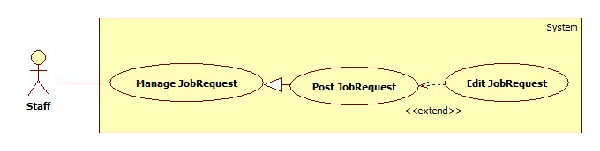

|  |  |  |  |  |
| --- | --- | --- | --- | --- |
| **USE CASE SPECIFICATION** | | | | |
| **Use-case No.** | UC042 | **Use-case Version** | | 1.0 |
| **Use-case Name** | Edit jobrequest | | | |
| **Author** | CongNT | | | |
| **Date** | 21/09/2014 | **Priority** | High | |
| **Actor:** Staff  **Summary:** This use case allow staff edit jobrequest  **Goal:** Staff can edit jobrequest  **Trigger:** User login as staff  **Pre-conditions:**   * Page is loaded successfully * User login as staff successful   **Post conditions:**   * Success: Login successfully, staff can edit maids * Failure:   **Main Success Scenario:**   |  |  | | --- | --- | | Actor Action | System Response | | 1. Login as a staff 2. Click name link 3. Click maid name link 4. Click title link at “Chờ nhận” tab or “Tạm ẩn” tab 5. Click “Sửa thông tin yêu cầu công việc” link | 1. System redirect home page 2. System redirect personal profile page 3. System redirect maid profile page 4. System redirect jobrequest info page 5. System redirect edit jobrequest page with following field:  * Đăng cho [MaidName: textbox] * Tiêu đề [Title: dropdownlist] * Các kỹ năng [SkillRefId: textbox] * Thời hạn đăng [PostTime: textbox] * “Sửa thông tin” button |   **Alternative Scenario:**   |  |  | | --- | --- | | Actor Action | System Response | | 1. Click on the “Đăng xuất” button. | 1. Clear session and back to home page |   **Exceptions:**   |  |  | | --- | --- | | Actor Action | System Response | | 1. “Họ và tên” is empty 2. “Số điện thoại” is empty or not a numberic value 3. “Ngày sinh” is empty | 1. Show message “Vui lòng nhập tên người giúp việc” 2. Show message “Vui lòng nhập số” 3. Show message “Vui lòng chọn ngày sinh” |   **Relationships:** N/A  **Business Rules:** Staff | | | | |

### Software System Attributes

#### Reliability

* There is no requirement for system maintenance task from the user.
* Mean Time Between Failures (MTBF): more than 6 months.
* Accuracy: 100%.
* Maximum Bugs and Defect Rate: 0.3 bugs per thousand lines of code (0.3bugs/KLOC).
* Critical bugs:
* Loss of data: not any

#### Availability

* The server shall be working 24 hours per day and 7 days per week.

#### Security

* *All sensitive* information (password, etc.) must be hashed when storing in database and during transmission over networks using MD5 hash.
* Validate input data in SQL query before execute to avoid SQL Injection, XSS
* The role of user and member is clearly.

#### Maintainability

* All code shall fully document. All program files shall include comments concerning authorship and date of last change.
* The code shall be modular to permit future modifications.

#### Portability

* The software will design as cross-platform software.

#### Performance

* Large tables and indexes must be partitioned data into smaller, more manageable sections by using partition in SQL Server 2008 R2

## Entity Relationship Diagram or Data Structures

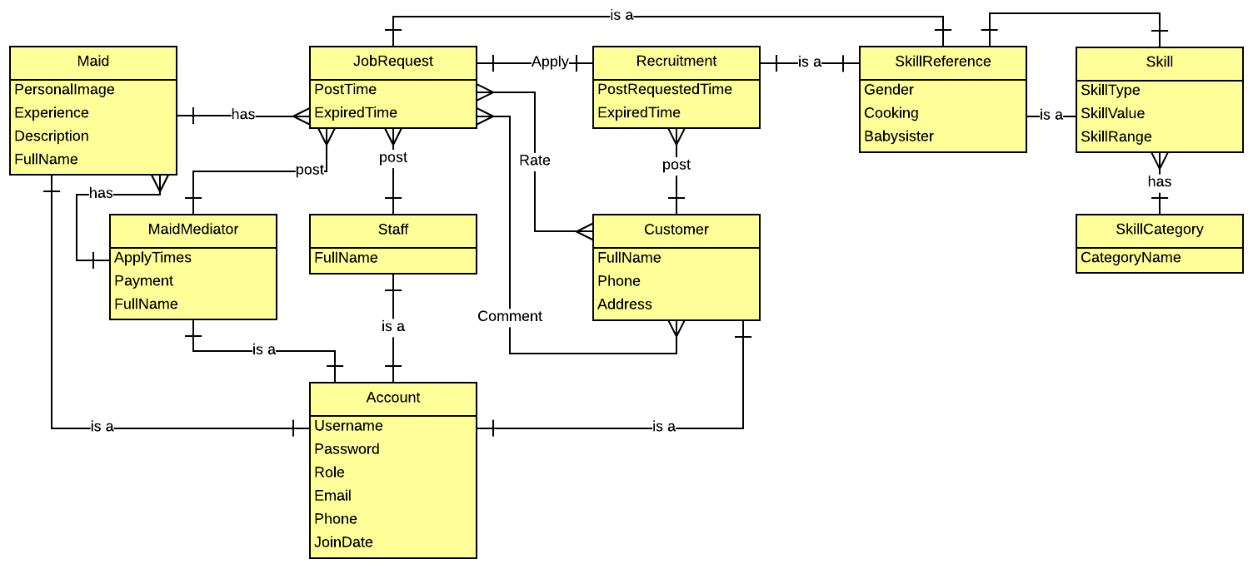

## Other material (if any)

N/A